Anexa 1 – Scurtă prezentare a proiectului (engleză)
INSIDE OUT – Reconnect the Participatory City with Everyday People
Concept Note URBACT Action Planning Network
7 maart 2023
Entiteit City of Ghent
Policy Participation Unit
Contactpersoon Lise Hullebroeck

Why URBACT?
URBACT offers cities a unique opportunity to learn from other peers in Europe in order to improve the way cities are managed. URBACT networks foster the exchange of experience and good practice across cities, building urban stakeholders’ capacity to develop efficient solutions. One could say that URBACT is an accelerator of sustainable integrated urban development in Europe enabling cities to benefit from the tried and tested URBACT Method.
URBACT IV (2021 - 2027) continues to bring cities together with its first call for Action Planning Networks, open from 9 January to 31 March 2023.

Urban challenge/issue to be specifically addressed by the Action Planning Network “INSIDE OUT”
In recent decades, several European cities focused on developing and rolling out a broad and ambitious idea of participation. On all steps of the participation ladder, participation instruments and co-creative initiatives were developed and stimulated, for and with citizens, in all their diversity and variety.
Parallel to this movement, another idea germinated in Europes (and by extension global) societies and cities: namely, a growing sentiment of not being represented by the government, sometimes crystallised in a distrust of official bodies.
This presents us, local governments, with a gigantic challenge. Our highly developed participatory system - the participatory city - rests on an essential premise, namely that those who participate in it trust that government. And that is precisely where the shoe pinches. This once great trust is eroding.
Based on past contacts with other European cities and literature/articles in the press, we as lead partner (Ghent) could conclude that other European cities also face the same challenge.
This has strengthened our conviction that this is a problem faced by many European cities, including those with a long tradition of participatory work. Precisely those cities are confronted with a paradox: namely, that the many efforts to stay connected with residents seem insufficient to overcome the growing feeling among citizens of no longer being represented/not being heard.
Therefore, through the urbact network nine European cities are eager to exchange on the challenges we face but even more on the different solutions cities are already applying today and think about new solutions together.
We would like to work and exchange on three areas:
- To find out why a growing number of residents feel less represented and what causes this. To do this, it is important to gain a good understanding of the needs and requirements of the residents and users of the city so that a city can form its policy on the basis of the lifeworld of its residents.
- Exchange and develop new methods and approaches in which the government participates in the life of the city's inhabitants and not the other way around. It is important to look for direct ways of participation that are close to the living environment (so called lifeworld) of the citizens, so that the silent majority is also reached who does not spontaneously participate in the participation initiatives organised by the city.
- Organisational and political shift: the above approaches search for new types of connections between the existing political democratic system on the one hand and the power of the autonomous citizens and civil society on the other hand. This approach demands a more open, accessible positioning of local governments and a will to share and redistribute decision power with citizens, such as citizen panels (through drawing lots), participatory budgeting, crowdsourcing, .. but it could also be by other experiments that challenge, develop, test and implement ideas that trigger a process of broader local change.

Partnership of 8 cities
The partnership will contain the following 8 cities
- Ghent (lead partner)
- Banska Bystrica (SLOW)
- Bari (IT)
- Ostrava (CZ)
- Rennes (FR)
- Rotterdam (NL)
- Tampere (FI)
- Timisoara (RO)

Partner’s Role
The Inside Out project will be built around 3 working packages:
- WP 1 - Network Management – will be taken up by the lead partner City of Ghent;
- WP 2 – Network Level Activities – will bring together all 8 Action Planning Network (APN) partners for transnational exchange of experience and good practice across cities.
  - Activities include 6 Transnational Meetings (in-person) for all partners & a minimum of 4 online meetings, depending on the needs of the APN partners and to be defined in further detail based on baseline studies carried out by the lead expert in each of the 8 APN cities. These exchange and learning activities will contribute to the production of an Integrated Action Plan by each partner.
- WP 3 – Local Level Activities – will support all partners at local level in building their urban stakeholders’ capacity to develop efficient solutions to local challenges defined in the project.
  - Each of the 8 APN cities will appoint an ULG coordinator to set up an Urbact Local Group (ULG), bringing together relevant local stakeholders (representatives from city administration, politicians, civil society, private sector, knowledge institutions, …) related to the local challenge defined in the project. The ULG will contribute to the production of the Integrated Action Plan.
A continuous interaction and exchange of experience and expertise between the transnational (WP2) and local levels (WP3) is important throughout the project period, starting from 1st June 2023 – 31st December 2025. Both transnational and local level activities will be supported by a lead expert and several thematic experts (directly paid by Urbact, so on top of the overall project budget), based on the needs (thematic and methodological) identified by the APN partners, and will contribute to the production of an Integrated Action Plan in each of the 8 APN cities.
A budget to support the above activities is available at both transnational network and local partner level to pay for staff costs, travel costs, and external expertise (e.g. for ULG capacity building, experiments to tackle local challenges).
The figure below gives an overview of the different stages in the project’s lifetime as well as the activities and outputs that will be generated by collaboration between the lead partner, the project partners, the lead expert and thematic experts.
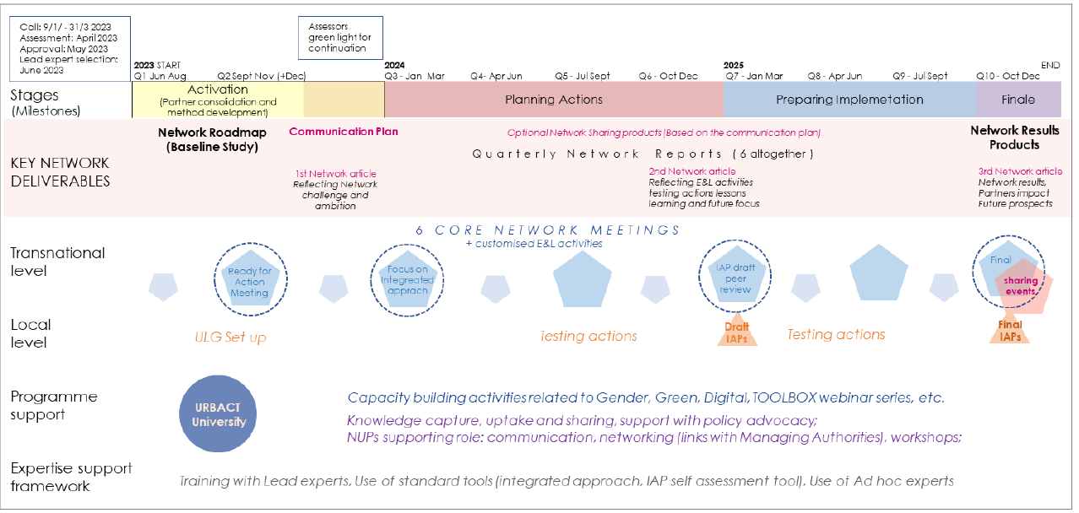

During the activation stage (from June to December 2023) partners will attend the following meetings to initiate the Inside Out project:
- Attendance (online) Urbact launch meeting on 22 June 2023
- Attendance (online) at the kick off meeting of the APN Inside Out – (date tbc June 2023)
- Attendance (physical) at Urbact Summer University in week of 28th August 2023
- Attendance (physical) at first Core Network meeting – Sept-Dec 2023 (date tbc)
- Each partner to host a 2 day visit of Lead Expert in your city to develop a baseline study

For more information on the Inside Out project, please contact: participatiepunt@stad.gent

